BRIEF ABOUT SAFE USE OF THE SCOUT HQ FACILITIES

CAR PARK

Combination padlock 2512 (Memory hint: Christmas Day)

UNLOCKING

Unlock main door. Go in. Enter Alarm code - ISSUED SEPARATLY . Room light is automatic.

Unlock the internal 'facing' door to the Social Area – this must be unlocked when the building is occupied as it is part of the fire escape route

UPON LEAVING

Make sure that all rooms are empty and that the building has been vacated.

Make sure that all lights are off and that the big display monitor in the large meeting room is switched off using the remote control and that any electric heaters are also switched off

Ensure that all internal doors are shut properly as they are fire doors.

Lock the door to the Social Area

Unlock the front door if it has been locked for security purposes.

Enter the issued four-digit code

Wait for your name to come up on the screen and when it asks if you want to set the alarm.

Press the button labelled √
The alarm will sound for about half a minute.
Exit during this period.

Lock the front door from the outside.

Close the carpark gate and lock it rolling the code to conceal it.

Securing the building if only using the upstairs rooms

While using the upstairs facility only, it is advisable to lock the front door for security.

There is a wireless doorbell fitted with a sounder on the first floor as well as in the social

Briefing notes for building users are in each area. This confirms the following

Please note: The organiser/leader of the meeting is the designated Scouter in Charge

Please ensure these are briefed to all members of the meeting/event

Confirm the location of the toilets one on each floor

There is a lift for use for anyone who has limited mobility however this is not to be used in the event of a fire.

There are no fire alarm tests scheduled during the meeting/event. In the event of the alarm sounding, please evacuate the building using either the main entrance or the exit via the shop. There is an additional exit via one of the windows in the main meeting room which can be fully opened. In the event of a fire, in the first instance, anyone with limited mobility to be supported/carried downstairs. If this is not possible, the designated refuge area is at the top of the stairs

Ensure that all internal fire doors are closed as you leave in the event of an evacuation

Report to the assembly point on Lyon Street outside the railings to Park Royal School where your leader/scouter in charge will take a role call. Call the Fire Brigade on 999.

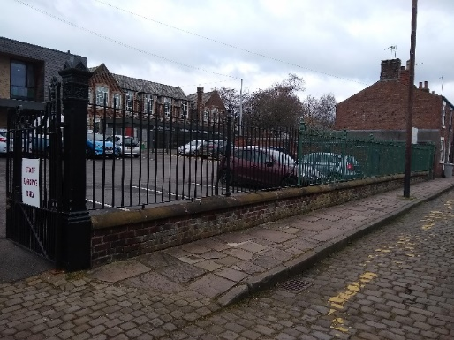

The address of the District HQ is

32 West Bond St

Macclesfield

SK11 3EQ

Do Not:

Delay your evacuation to collect personal items;

Re-enter the location until it is safe to do so as determined by either the Fire Brigade, Scouter in Charge or your leader

There is a first aid kit available in the downstairs social area in the cupboard marked with the green sign. There is also an AED – defibrillator in the same location. The Scouter in Charge/Leader must ensure that all accidents must be recorded in the accident book located with the first aid kit. If the accident is serious and warrants reporting in line with

the Scout Associations Purple Card then the District Lead Volunteer must be informed immediately.

For non- scouting users of HQ, any accidents that require the emergency services or a visit to hospital, please inform Ian Mackintosh on 07917 373007.

There are tea/coffee making facilities on each floor. Please wash up after using any cups/mugs

Lift
The lift is called and used in the normal way, except all buttons must be manually held down continuously until the lift arrives or the door unlocks

IMPORTANT. THE LIFT SHOULD NEVER BE USED BY ONE PERSON ALONE IN THE BUILDING. The lift is not connected to a source of help and a single person could become trapped in the lift without any prospect of rescue other than through the use of a mobile phone. The emergency phone number of Sherridan Lifts is at the call points and in the lift itself

Occupancy
The room limits to the number of people using the upstairs rooms is as follows
Large meeting room - 35
Medium meeting room – 8
Small Office – 4

Toilets
There are two toilets, one on the ground floor and one upstairs. They are both unisex and disabled facilities. In both toilets there is an emergency cord which can be pulled if assistance is needed. However, this just sounds a visual and aural alarm in the building and is not connected to any external source of help. The alarm can be reset using the wall-mounted switch inside the toilet door. If an emergency necessitates help being given to someone using the toilet facility, then a screwdriver or coin will turn the lock from the outside to gain access and render assistance.

Please leave the entire premises in the same clean and tidy condition in which you found it.

Buildings Manual

Instructions for using the equipment in HQ can be found in the Buildings Manual which is a yellow project folder next to the Fire Alarm Panel by the main entrance. There is a fuller version in the yellow leaver arch file on the bookcase in the Social Area.

If a boost is required for the heating, the remote controller and instructions are located next to the printer in the downstairs office area.

Risk Assessments and SHE Documents

Copies of the risk assessments can be found in the following locations
Upstairs Office Notice Board, Yellow Lever Arch File Social Area and Social Area Noticeboard Buildings RA, Maintenance RA, Lone Working RA and Policy

Building RA
Yellow project folder main entrance

Social Area – Red and Green Lever Arch files
Fire Risk Assessment, Legionella Risk Assessment, Asbestos Survey, Routine external checks on equipment.

Please note the following key issues from the RA’s

Lone Working: Anyone lone working at HQ must carry a phone and ensure someone knows they are working at HQ. It is strongly recommended that the doors are locked when lone working. No access to the cellar or using the lift whilst lone working.

Slips and Trips: In cold weather – grit will be available in the bin in the car park.

Fire: The building and car park are designated No Smoking areas. Please ensure that all heaters are switched off at the ends of meetings.
Please familiarise yourself with the Fire Evacuation Plan that is displayed around the building.

Please familiarise yourself with the Fire Extinguisher Training Document so you are able to select the correct extinguisher in the event of a fire.

Services Cut Off
These are in the buildings manual and on the noticeboard in the Social/Office area downstairs

Maintenance:
Before commencing any maintenance work in the building, please review the Maintenance RA – locations detailed above - and follow all the controls that are detailed in the Maintenance RA.

----------------------------

If assistance is needed for any reason, then please contact
Ian Mackintosh
07917 373 007
01625 410 838
ianmackintosh@gmail.com

Version 4 13.11.25

